## ExceptionsException class

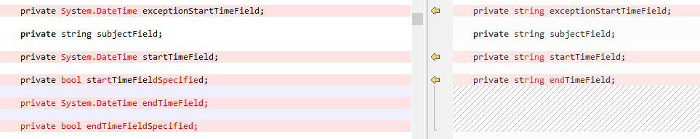





## GetItemEstimate class

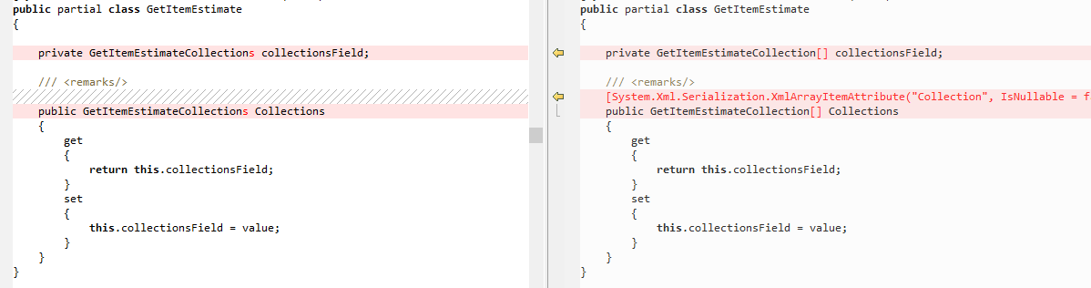

## AirSync class



## ItemsChoiceType3 enum

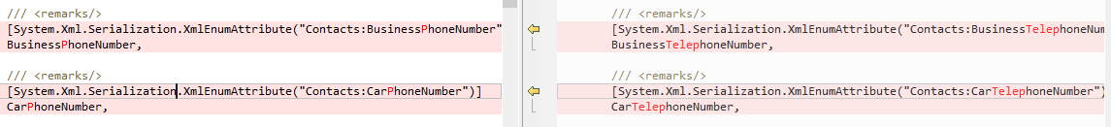











## MeetingRequest class





## Properties class

## queryTypeLessThan class

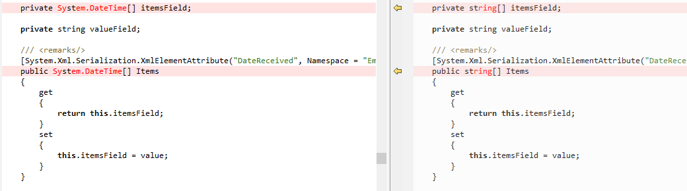





## Recurrence1 class



## Schema class



## Supported class



## SyncCollectionChangeApplicationData class